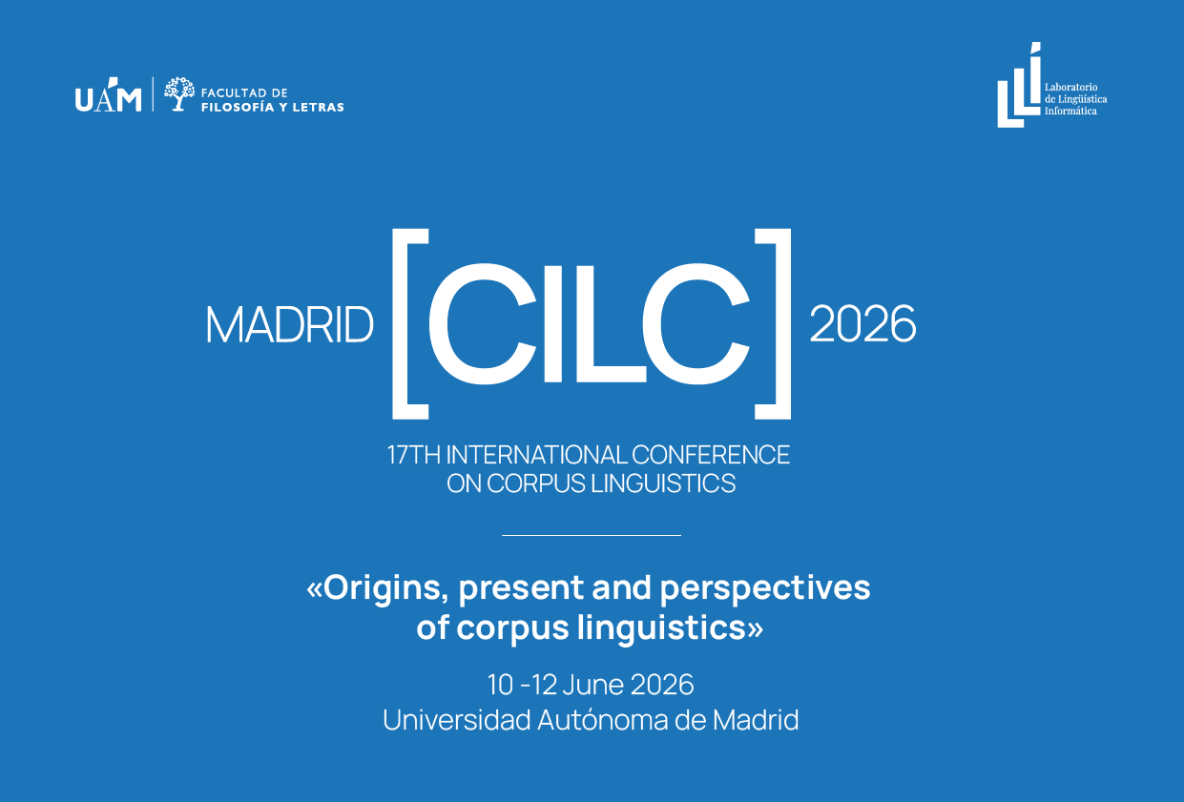

IMPORTANT DATES
- Abstract submission: 24 October 2025 – 22 December 2025 EXTENDED UNTIL JANUARY 10, 2026
- Notification of acceptance: 10 February 2026
- Registration: 12 January 2026 – 20 April 2026
  - Early bird: 12 January 2026 – 26 March 2026
  - Regular: 27 March 2026 – 5 May 2026

- Conference dates: 10 -12 June 2026

CONFERENCE DESCRIPTION
The seventeenth edition of AELINCO's International Conference on Corpus Linguistics (CILC2026) will be held at the Autonomous University of Madrid in June 2026. The conference is organised locally by the Computational Linguistics Laboratory (LLI-UAM) of the Department of General Linguistics and Modern Languages of the Faculty of Philosophy and Letters. Founded in 1988, the LLI-UAM is one of the oldest laboratories in the country in the field of computational linguistics and corpus linguistics. Its founding milestone was the compilation of the Reference Spoken Corpus of Contemporary Spanish (CORLEC) in 1990-92, followed by multiple oral and written corpora, such as C-ORAL-ROM and the UAM Spanish Treebank. Recently, a bilingual Spanish-English corpus of financial texts, FinT-esp, has been compiled in collaboration with the UCREL team at Lancaster.
This edition of CILC will have as its theme ‘Origins, present and perspectives of corpus linguistics’. The aim is to integrate, from an evolutionary perspective, the initial contributions of the first researchers in the field with current achievements and future projections. In our opinion, this is the most comprehensive way to appreciate the evolution of the discipline, both in terms of data acquisition, registration and classification, and in the development of computational tools to manage it and, consequently, with advances in the empirical analysis of texts. We also encourage participants to submit their work in any linguistic register, without language restrictions. The multilingual, multimodal and international nature of the conferences organised by AELINCO is their very essence.

The modern campus of the Autonomous University of Madrid, inspired by 1960s campuses such as Stanford, will host the academic sessions of the conference. Located 15 km north of Madrid, among pine forests and gardens planted with trees over fifty years old, the Cantoblanco campus brings together a large number of faculties and associated centres of the CSIC, together with a science and technology park, in an environment where multidisciplinarity is the backbone. Well connected by Cercanías trains, intercity buses and with north and south access for private vehicles, it offers guaranteed access to its facilities from the city of Madrid or nearby cities such as Alcobendas or Tres Cantos. There is a variety of catering services, as well as libraries and rest areas in the shade of leafy trees.

Following the tradition of AELINCO conferences, CILC2026 will take place over three days: from 10 to 12 June. Along with contributions from participants, who will share the latest advances in their areas of work, there will be plenary lectures by internationally renowned specialists, as well as workshops and round tables.

On this occasion, in line with previous conferences, we will have the unique contribution of the following specialists:

- Dr. Francisco Marcos Marín (Professor Emeritus at the University of San Antonio, Texas)
- Dr. Núria Bel (Professor at University of Pompeu Fabra, Barcelona).
- Dr. Inés Fernández-Ordóñez (Professor at Autonomous University of Madrid).
- Dr. António Branco (Professor at University of Lisboa, former chair of LREC).

We encourage all interested parties to start preparing their proposals. Updated information will be available on the website from September 2025 onwards, on the Computational Linguistics Laboratory website. (https://www.lllf.uam.es).

PROPOSALS
Prospect speakers are welcome to submit abstract proposals contributing to any one of the nine AELINCO thematic panels:

- Corpus design, compilation and types
- Discourse, literary analysis and corpora
- Corpus-based grammatical studies
- Corpus-based lexicology and lexicography
- Corpora, contrastive studies and translation
- Linguistic variation and change through corpora
- Corpus-based computational linguistics
- Corpora, language acquisition and teaching
- Special uses of corpus linguistics

Abstracts may be submitted in communication or poster format and should be 400-500 words (excluding references). They should clearly indicate the main research question(s), the methodology, and (anticipated/ provisional) findings. They should be anonymous and sent attached by the following form that can be found on the conference’s website, according to the following formatting guidelines:

- Thematic panel: centred, italics, font Times New Roman 12 pt
- Title: centred, bold, font Times New Roman 14 pt
- Keywords: up to 5, in italics, font Times New Roman 12 pt (below the title).
- Main text: justified, font Times New Roman 12 pt, interspacing 1
- References: APA7
- Format: .DOCX and .PDF

Please attach a second Word .DOCX file with the non-anonymized version, containing the title of your abstract, your name(s), affiliation(s), e-mail(s) and full abstract with the references.

Each participant may submit a maximum of two proposals in English or Spanish from 24 October 2025 to 10 January 2026.

- COMMUNICATION: 20-MINUTES ORAL PRESENTATION + 10-MINUTES DISCUSSION.

2 POSTERS: Once they have been accepted, posters should comply with the following format:
- Dimensions: A0
  - Height: 1189 mm = 118.9 cm
  - Width: 841 mm = 84.1 cm
- Content
  - Title: At the top, minimum font 42 pt
  - Authors and affiliation: below the title
  - Main text: minimum font 17 pt

Please note that being a member of AELINCO is an absolute prerequisite for participation as a speaker. If you are interested in becoming member of AELINCO, you may find further details about the application process on the AELINCO website.

Notes:
Presenters are advised to register before 26 March.
No cancellation reimbursements can be done after 5 May.

PUBLICATIONS

As in previous editions, once the conference has taken place, we hope to publish a volume with a selection of contributions on the conference theme with a prestigious publisher in the field and/or a special issue in RiCL (Research in Corpus Linguistics).

CONTACT
If you have any questions about the conference, please contact us at: cilc-2026@uam.es

Information about the conference fee, accommodation, etc. will be posted on the conference website before the end of the year, keep an eye on it and follow us on LinkedIn!

ORGANISING COMITTEE
Antonio Moreno-Sandoval
Avelino Corral
Jordi Porta
Sofía Roseti
Yanco Torterolo
Gala Arias
Paula Gozalo

